PORK SA MEMBERS’ INDUSTRIAL RELATIONS

FEBRUARY 2025 UPDATE
What’s Happening in Industrial Relations between early 2025?
1ST JANUARY 2025 - NEW WAGE THEFT LAWS
These laws came into effect on 1st January 2025 and will make it a criminal offence for an employer to intentionally underpay its employees their entitlements under the Fair Work Act 2009 or an industrial instrument (Enterprise Agreement, Individual Flexible Agreements (IFA), or any other agreement. This extends to non-payment of superannuation and long service leave entitlements.
It is often stated that “Above Award” rate or salary is paid. That arrangement must meet the Better Off Overall Test (“BOOT”) by including all Award provisions including allowances, and overtime payments as well as the National Employment Standards (“NES”). Paying “above Award” means paying above all Award entitlements not just the wage rate and applies when arranging salaries.
Underpayments can occur deliberately or unintentionally, but if intentional, prosecution may be likely. If prosecution succeeds it will be a criminal offence.
Pecuniary penalties also apply for non-payment of entitlements for successful claims for under payment of wages, leave and superannuation entitlements. This may include non-payment of wages, leave, and superannuation. Pecuniary penalties seek to punish employers who do not pay Award and NES entitlements.
It is time to check if you are paying correctly including wage rates, allowances, overtime, leave entitlements, and superannuation.
If you think that there are underpayments, please seek advice to rectify urgently.
PSYCHOSOCIAL HAZARDS
Changes to the Regulations under the Work Health and Safety Act 2012 are intended to help workers and employers to manage the risk of psychological injuries and illnesses in the workplace. These requirements have now come into effect.
These new Regulations reflect the outcomes of an independent review of Australia’s model Work Health and Safety laws, which recommended more specific guidance how to identify and manage psychosocial risks.
Psychosocial hazards are regarded to cause psychological harm. Examples range from excessive workload demands, to exposure to traumatic events and material, to issues such as bullying, harassment, and sexual discrimination in the workplace.
SafeWork SA has advised that it considers psychosocial hazards to be a workplace health and safety issue as they can create physical or psychological risk to worker health and safety.

Psychosocial hazards include the management of work that increases the risk of work-related anxiety. Visit https://www.safework.sa.gov.au/workpl... for resources to help identify and manage the risks of psychosocial hazards in the workplace.
Examples include:
- Job demands.
- Low job control
- Poor support
- Poor role clarity
- Poor organisational change management
- Inadequate reward and recognition
- Poor organisational justice
- Traumatic events or material
- Remote or isolated work
- Conflict or poor workplace relationships
- Poor physical environment
- Fatigue
- Bullying
- Sexual harassment
- Harassment
- Violence and aggression

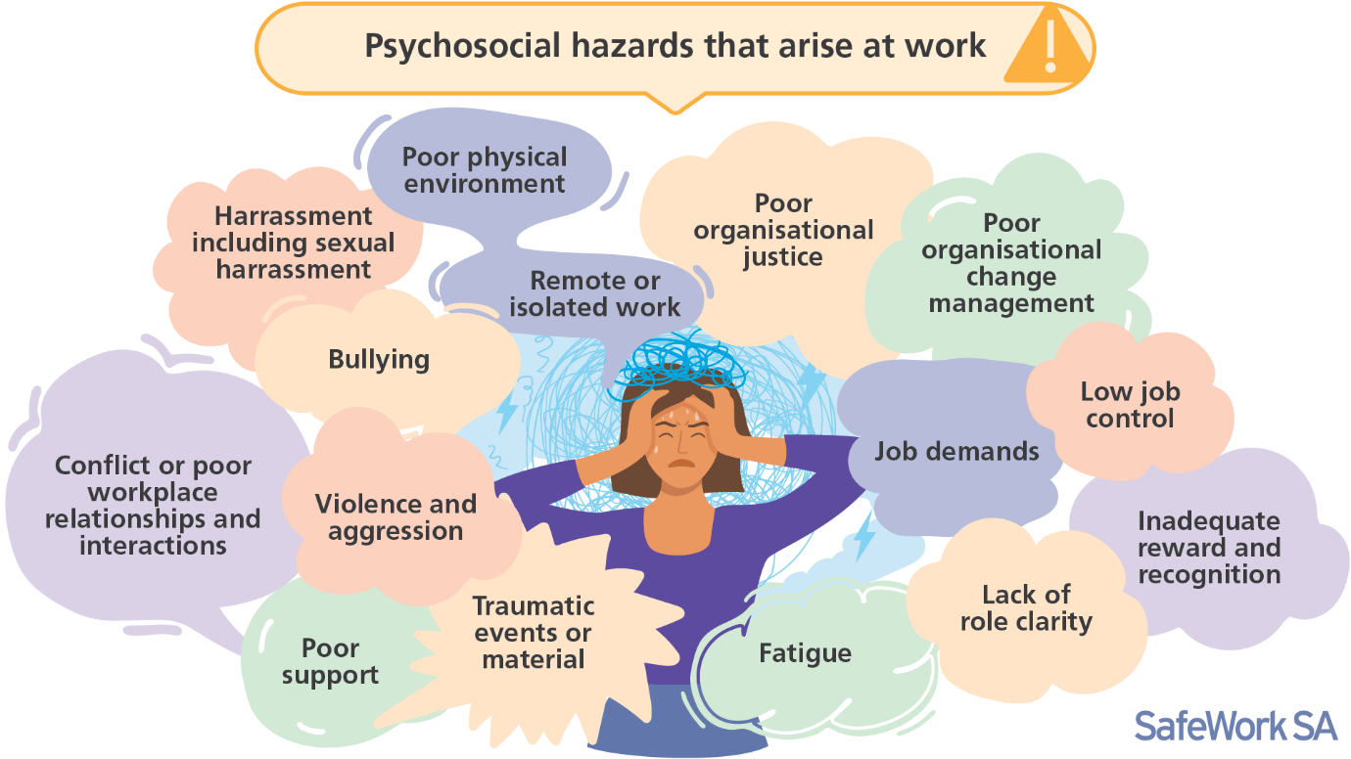
For more information refer to the Code of Practice on Managing psychosocial hazards (external site) at work which will provide practical guidance on how to manage risks to psychological health, developed in consultation with workers and businesses.
The intention is for prevention psychological harm as an essential part of creating a safe and healthy workplace.
'These new Regulations are part of a significant national effort to better address the risks caused by psychosocial hazards at work and recognise that a worker’s psychological health is just as important as their physical health,' said the Minister.
The amount of information available maybe overwhelming but Page 114 at Farmers’ Guidebook to work health and safety(PDF) and as a small employer this link provides advice and assistance www.safework.sa.gov.au/__data/assets/pdf_file/0004/918688/Psychological-health-for-small-business-SWSA-Branded-v2.pdf
1st APRIL 2025

More information will be made available in the next Update to explain changes to the lowest classifications in the Award and induction training.

MEMBERS ADVISORY SERVICE

PorkSA members are entitled to contact MERS for a free half hour consultation, per member per year. Our telephone number is 08 83312422) and email info@mers.com.au

Chas Cini
Principal

